Hamlet Comes Alive!
(wt 2)

For this assignment, you have the opportunity to choose one of the following performance tasks to create and present a captivating and engaging presentation for this term’s Drama Festival. Either on your own, or with your peers, you will write, plan, and perform one of the following dramatic compositions outlined below.

In your writing of the script, journal entries, and performance, you and your group members are required to demonstrate your understanding of the characters, themes, plot, and conflicts that exist in Hamlet.

You are encouraged to incorporate skills and abilities such as playing a musical instrument, song writing, singing, dancing, martial arts, visual arts, clowning, juggling, and more. During the creative process make sure to apply the techniques outlined in Fig 6.2, the writing and creative strategies from the handouts, and acting tips learned in class.

FOR EACH OPTION, COMPLETE THE FOLLOWING:
- Individual Drama Journals, which articulates your daily process, responsibilities, contributions, and character development.
- Group or Individual conferencing with the teacher based on the performance option you have chosen. Set an outline of jobs, tasks, deadlines, and rehearsal schedule to create your performance. Be innovative and original, overlapping of ideas will not be permitted.
- Apply acting and writing techniques learned in class
- Share equal responsibility in the creative process, which includes:
  - Writing
  - Technical Design
  - Rehearsals.
- Share performance time equally
- Memorize lines: acting and delivery of lines should be believable and authentic
- Consider your use of space on stage.
- Create set design and use appropriate props
- Consider sound and lighting options
- Use appropriate make-up and costume design
- Incorporate the audience in a creative way
- Create a program guide that includes a brief synopsis of your performance, headshots with a brief bio, the roles you will be playing, and credits. (Brief is 5-6 sentences)

IMPORTANT:
- Assign specific jobs from the start and deadlines for people to complete their tasks. Make sure everyone has something to do. Share the workload. Be accountable and helpful!
- Start with the script and get it done as soon as possible so everyone has adequate time to memorize his or her lines.

DRAMA JOURNAL:
Your Drama Journal [DJ] is a daily log that you will use to record your learning, work, suggestions, and opinions. It should be organized neatly and logically, with dates and headlines. Your teacher will assign the format for your DJ.
You will include in your Drama Journal:
- Proposal: Roles, Tasks, Responsibilities, Deadlines, and rehearsal schedule
- Daily reflections and evaluations of your work
- Your process work
- Your bio and outline of your contributions to the creation of the Program

In class work periods
Mon | Tuesday | Wednesday | Thursday | Friday
 |  |  | 04/24 - Work Period | 04/25 - Conferencing
04/28 - Work Period | 04/29 - Work Period | 04/30 - Work Period | 05/01- Holiday | 05/02 - BL
05/05 - Work Period | 06/05 - Work Period | 04/07 - Work Period | 05/08 - Work Period  *Drama Festival* | 05/08 - BL
05/09 – DJ’s Due

The Creative Process
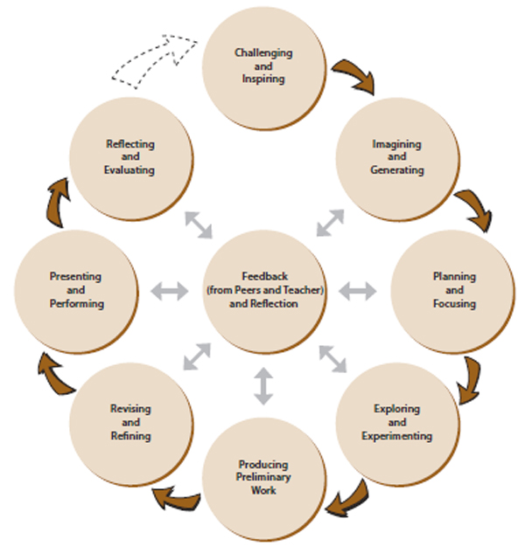
Your options include:

A: The Juries Out
In groups of 5 to 6, you will create a 10-12 minute dramatic performance of a modern day trial. You will put one of the characters on trial for a crime or wrongdoing that occurs in Hamlet. You can play more than one role in order to create a more complex and interesting performance. For example, you may put Hamlet on trial for the death of Polonius.
Both defense attorney and prosecutor will need to have an argument, claims, and evidence to prove your point. You will need questions to ask each other’s witnesses, just as you would in a real courtroom. Remember to stay true to the relationships, personalities, and themes that exist within the play.
You may need the following:
- Witnesses – give statements to support your claims.
- Defense attorney
- Prosecuting attorney
- Court reporter
- Bailiff
- Judge and jury. You could make the jury the audience and have them rule on whether the character is innocent or guilty.
B: Masterpiece Theatre
In groups of 3-4, choose two or three Shakespearean characters to create an original 6-8 minute performance. Each character must be from a different work. Keeping the characters and the issues surrounding them intact, develop a scene where the characters interact with one another. The scene must take place in a setting that is not of their time period. For example, you might choose the characters Hamlet, Lady Macbeth, and King Lear and place them in a family counseling session because of the conflicts they experience with their family members. Or you might have a teenaged Hamlet trying to serve two incredibly difficult customers, Lady Macbeth and King Lear.
- Choose characters that have something in common
- Choose a setting that will contribute to conflict
- Include in your scene as many lines from the original texts as you can
- When writing new lines for each character, make an effort to write in the original voice of the characters. This does not mean that you must write in iambic pentameter; however you want some consistency between the character’s original lines and the ones you create.
- Be sure to stay true to the character’s traits. For example, in Macbeth, Lady Macbeth is driven by her ambition. Therefore, she should also be ambitious in the scene you create.

C: Don’t forget about me!
On your own, you will explore the opinions and relationships of one character from Hamlet that had a small or unexplored role in the play. You will create a 2-3 minute original monologue in a modern day setting. Research and analyze the characters personality, opinions, motives, objectives, and relationships with the other characters. Your writing must stay true to the play’s themes, characters personality, and relationships. For example, in your monologue you may wish to explore Rosencratz relationship to Hamlet and Guildenstern in his dorm room in a New Zealand University.

D: An I for an I “Revenge should have no bounds” - Hamlet
Using Shakespearean style, create an original character, write an original 2-3 minute soliloquy in which the character vows revenge, and perform the soliloquy. The soliloquy must answer: 1) Why the character is seeking revenge; 2) Who the character wants to avenge; 3) How the character will achieve revenge.
TIPS:
- Consider writing your soliloquy in blank verse.
- Decide how your character will deliver the soliloquy. Standing? In a chair? Walking around?

E: Evening News
In groups of 3 or 4, write and film a 6-8 minute breaking news special that would occur at the end of an Act of your choice. Your report needs to stay true to the events that occurred in the play, include an outside opinion, and evidence. Remember to include within your scene a conflict, stakes, climax, and resolution. You will need to include the the following:
- Anchorman
- On-scene reports
- Camera man
- Witnesses.

F: Elevator Play
In a group of 5 or 6, you will explore the personalities, age, status, and problems of 5 to 6 characters from Hamlet within a fixed and confined location. It is the tension between the characters that drives the play. The play should be between 10 to 12 minutes in length. In order to create consider the following:
- Location: a bank vault, a submarine, an elevator, a walk-in refrigerator. The set should be created to illustrate the close quarters the characters are in.
- The point of attack that triggers the problem should occur at the beginning of the scene after all characters have entered the stage.
- Provide each of your characters with a clear objective.
- The inciting incident occurs when the characters become stuck or locked in the location
- The conflict occurs when the characters become strained and clash with one another.
- The climax is often when one character reaches a breaking point.
- The resolution is when the characters are set free or something dire occurs.
- Consider the physical creation of the roles. The physical appearance you give your characters will help limit the need to “introduce” the character.

G: Talk Show with…?
In groups of 2 or 3, you will film a 5 to 6 minute ‘live’ interview with one or two of the characters or William Shakespeare himself. Make sure you research your roles, come up with relevant and intriguing questions with detail to the themes and conflicts that exist in the play, develop complex answers, and create a believable conflict. Your interview should demonstrate your knowledge of themes, characters in the play, plot, and writing techniques used in the play. Characters should express opinions that are believable and accurate.

H: Your own idea!
You have your own awesome idea that you want to create? Well now is the time to put your creativity to the test. All you need to do is write up a one-paragraph proposal with an outline of what you want to create for your performance, and have it approved from your teacher.

