Literature Circles – Stage 1

This should be SUNDAY NIGHT

- Click on the following link for your group. The groups are as follows (roles are not indicated because that would take me too much time to type, and I got a million things to do, and you should already know the roles):

 | Group 1 | Group 2 | Group 3 | Group 4
 | Nabila **  Jasmine  Vika  Yap  Nikki  Sharinia | Kenny  Shunta **  Jiajin  Fang Ee  Jeff | Dexter  Meyshna  Haziq  Andrew  Jamila**  Aemil** | Kelly  Sandra  Alex**  Ariel**  Aaron  Chino***
YouTube Video Group Link  CLICK IN THE BOX on Adobe Reader (PDF Reader) | http://www.youtube.com/playlist?list=PL_IFU_rMgzrTVot2ycIusDBhXQw_4bY4- | http://www.youtube.com/playlist?list=PL_IFU_rMgzrRhrY6mNV_stAJsytJ5q_7r | http://www.youtube.com/playlist?list=PL_IFU_rMgzrR2_2UPp7BIEZWd-LgQFT8D | http://www.youtube.com/playlist?list=PL_IFU_rMgzrQhUuYy3wwFT2OiUFgLxCFb
** - means as of the typing of this assignment (3pm on Sunday) they have not submitted their video. They may do it later, as to which I will upload it, but as of now it won’t be there. If this is embarrassing, sorry, but I don’t need 5 Celly messages telling me they don’t see “someone’s” video.
*** - particularly different case, so please excuse the video all together.

- Watch the videos, and take notes on paper or on your phone as to what you feel about the questions asked. Create:
  - Answers
  - Further Questions
  - Argumentative Points
  - Attempt to “push buttons” (say stuff that might upset or “rile-up” people; play “devil’s advocate”) If you don’t know what any of these terms means, for goodness sakes, Google them up.

- For those of you that have difficulty asking questions or saying answers that have further questions in them, please use some of these charts to help you analyze or ask further questions:
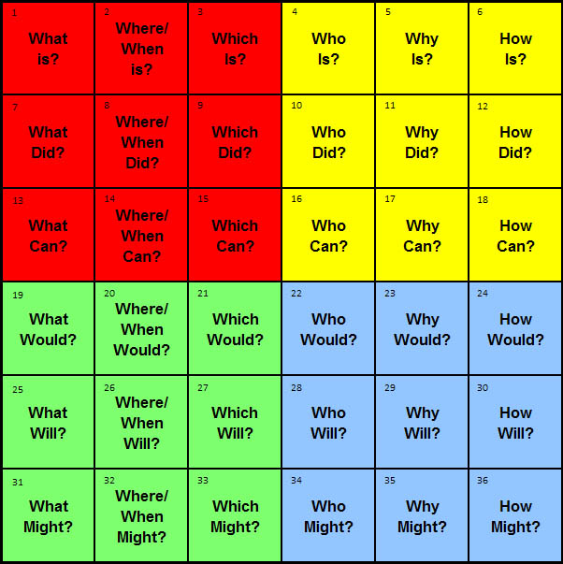
Considering All Points
Purpose: Challenge or contest a point of view that differs from your own (you don’t agree with a group member)

- Why did you say that?
- Is that a good enough reason?
- What are some possible explanations?
- How do you know?
- What would the consequences be…?
- Do those two ideas agree?
- How is THAT different from what I said?
- What questions would be useful to ask?
- What have we learned?

Figure 1- Q-Matrix Chart to Ask Deeper Questions
Chart 1- "Consider All Points" to challenge people's point of view

3 C’s and 3 P’s
Yet another item to help you ask good questions, and think about your thinking, and get ready to discuss and/or argue with your group members about some of the things they shared. Think about this before watching everyone’s video – try at least.

First, Think About It… |  |  | Then, Feel it and ACT ON IT
Critique | What do you know and believe (about this topic)?  What might you expect to happen or be shared?  What are the factors involved?  What are the gaps, silences, or things missing?  Whose view dominates?  What are the strengths and weaknesses? |  | Ponder  Perspectives | What is another way of thinking about this?  What perspective is missing?  How would the situation change if…?
Compare | What is your compare…?  What are the similarities between _____ and _______?  What are the differences between ______ and ________? |  | Personalize | If you had to choose ___ what would you decide?  What is your opinion?  What do you care most about?  Who might have a different point of view?  How could you apply your learning to your life?  How does this fit with your thinking when we started the unit?  How does this relate to you or your situation?  Have you changed your ideas? If so, how and why?  How do your actions influence others?
Connect | If you put all the factors together, what are the big ideas?  What are the main ideas?  What relationships can you make?  What are some of the causes and consequences? |  | Prioritize | What is the most important thought you have?  What is the least important?  Which point do you want to or need to address first?  What can you leave (to discuss ) later?

- Create a list of questions, ideas, thoughts, arguments, things you want to share, want to discuss, predict other people might say and then you’re going to say back, and come prepared with it tomorrow (Monday).

- Once you have finished, prepare yourself mentally for the discussion; imagine it’s like going to court. Look at the evaluation everyone’s going to put on you below and be ready for Monday.

Criteria
Completion of Tasks | 1 2 3 4 5
Contribution to Discussion | 1 2 3 4 5
Punctuality | 1 2 3 4 5
Responsibility | 1 2 3 4 5
Organization | 1 2 3 4 5
Respect for Others | 1 2 3 4 5
Overall Collaboration | 1 2 3 4 5

